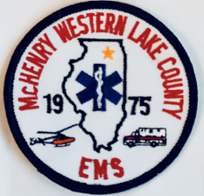

McHenry Western Lake County EMS System
System Memo #5
To: MWLC EMS PROVIDERS
From: MWLC EMS SYSTEM
Date: 5/4/2023
RE: Announcing Chris Kopera

The EMS office is excited to announce Chris Kopera has joined the MWLC team as a EMS educator. Chris has been an active member of MWLC dating back to 1996 as a paramedic. He holds a Masters in Science with a specialty in Fire Service and Homeland Security. Chris’s philosophy aligns with the values of the MWLC EMS System.
Please join us in welcoming Chris Kopera to our MWLC EMS team.

Chris Kopera
815-759-8046
Chistopher.Kopera@nm.org

